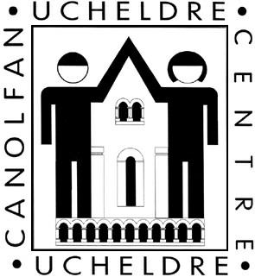

CYFELLION CANOLFAN UCHELDRE

Hoffwn ddod yn un o Gyfeillion Canolfan Ucheldre

ENW ……………………………….………………………………………………………………

CYFEIRIAD ………………………………………………………………………………………………
………………………………………………………………………………………………
CODPOST …………………………………………………………………………….………..

FFÔN ………..…………………………………………………………..……..………….
EBOST …..………………………………………………………………….......…………..

Dymunaf ymaelodi a thalu fel y ganlyn: (rhowch √ yn y blwch priodol)

GOSTYNGIADAU *£15 y flwyddyn
OEDOLION *£20 y flwyddyn

TEULU *£35 y flwyddyn
AELOD AM OES *£199.99 y flwyddyn

** I wish the Ucheldre Centre to reclaim tax on all my donations to the Centre, which includes my subscriptions, made on or after 6 April 2000.

Os ydych yn ymaelodi fel teulu, nodwch enw pob aelod o’r teulu (a’u hoedran os ydynt o dan 18 oed) sydd am ymuno â’r Gymdeithas:

…………………………………………………………………………………………………

………………………………………………………………………………………………….

………………………………………………………………………………………………….

Llofnod………………………………………………… Membership No
(Centre allocated)

Dyddiad………………………………………

* Pery aelodaeth o’r 1 Ebril – 31 Mawrth. Pan ymunwch bydd Staff y Ganolfan yn rhoi gwybod I chwi faint I’w dalu.
**Please delete if you are not a UK tax payer. Please remember to notify us if you no longer pay an amount of income tax or capital gains tax at least equal to the tax we reclaim on your donation (25p for every £1 you give).

Os gwelwch yn dda dychwelwch y ffurfien i: Canolfan Ucheldre, Banc Y Felin, Caergybi, LL65 1TE, (01407 763361). Dylech wneud eich siec yn daladwy i The Ucheldre Centre

