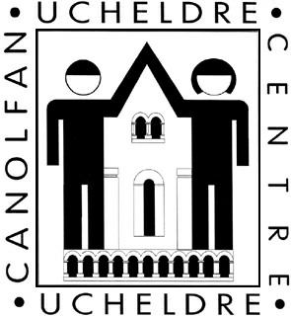

Application Form for Membership

FRIENDS OF THE UCHELDRE CENTRE

NAME ……………………………….………………………………………………………………

ADDRESS ………………………………………………………………………………………………
………………………………………………………………………………………………
POSTCODE …………………………………………………………………………….………..

TELEPHONE ………..…………………………………………………………..……..………….
E-MAIL …..………………………………………………………………….......…………..

I wish to take out a subscription as follows: (please tick the appropriate box)

CONCESSIONARY *£15 per year
PREMIUM *£20 per year

FAMILY *£35 per year
LIFE *£199.99

** I wish the Ucheldre Centre to reclaim tax on all my donations to the Centre, which includes my subscriptions, made on or after 6 April 2000.

For Family Membership, please give the full names (and ages, if under 18) of all other members of the family to whom the membership applies:

…………………………………………………………………………………………………

………………………………………………………………………………………………….

………………………………………………………………………………………………….

Signed………………………………………………… Membership No
(Centre allocated)

Dated………………………………………

*Membership runs from 1 April – 31 March. Centre Staff will let you know the correct subscription for the time of the year at which you are joining.
**Please delete if you are not a UK tax payer. Please remember to notify us if you no longer pay an amount of income tax or capital gains tax at least equal to the tax we reclaim on your donation (25p for every £1 you give).

Please return this form to The Ucheldre Centre, Millbank, Holyhead, LL65 1TE.
(01407 763361). Cheques should be made payable to The Ucheldre Centre.

